B PROJECT SYNOPSIS ON



**“ GSM based Home Automation System ”**

SUBMITTED TO

Sdbfksd K. GUJRAL PUNJAB TECHNICAL UNIVERSITY KAPURTHALA

In partial fulfillment of the requirement for the Award of degree of

Master of Computer Applications (MCA)

# Submitted by: Supervisor:

Rahul Bhandari Ms. Manmeet

2118889 Assistant Professor



# DEPARTMENT OF COMPUTER APPLICATIONS CGC LANDRAN

**MOHALI**

(2021-2023)

# ABSTRACT

This paper presentation is about implementation of a wireless real-time home automation system based on Arduino Uno microcontroller as main controller. Mobile phone is a revolutionary invention of the century. It was designed for making and receiving calls & text messages, but it has occupied the present generation through its trending applications. This project is about building a home automation system, where the user can control the home appliances by simple phone including a GSM module, just by sending SMS through the phone. In this project just a old GSM phone is enough to switch ON and OFF any home appliances from anywhere .The proposed system is shown to be a simple, cost effective which makes it suitable for the smart home future.

**INTRODUCTION**

As the name reflect the home automation system is related to the GSM. the automation system which runs on the GSM.

like Iot home automation system runs over the internet, Bluetooth home automation runs over Bluetooth. So it is very simple to understand what is GSM home automation system is.

A system that controls the electronics appliance over the GSM is known as the **GSM-based home automation** system.

in this system, we control things by our phone messages and call. we can trigger the system by call and message.

for example, if we store” bulb off ” in the code with the trigger condition and we send the same in the message to the gsm “bulb off” then the connected bulb will turn off.

this is **home automation using gsm** and Arduino. same as we can control the Bulb, Fan, AC, and many more appliances.

# GOALS AND OBJECTIVES

The main objective of this project is to design an IOT based home automation system in which an electronic device can be controlled through the commands sent from a mobile phone to the GSM which is to be considered as far field communication. This was an extension for the idea of controlling an electronic device using a Bluetooth module where it is considered as a near field communication. The system was designed to meet the requirement of controlling home appliances without any constrained path distance between user and the electronic device.

**PROBLEM STATEMENT**

The existing system also belongs to wireless domain but for a shorter range to communicate with its devices. The system can be controlled by sending the commands from a mobile through bluetooth connectivity. The system (controller with input and output peripherals) is associated with a HC-05 bluetooth module which then paired up with mobile Bluetooth. This creates a channel between system and user so that he can control the system using some operational commands. The user needs to install a mobile application called “BLUETOOTH   
TERMINAL”. This interface is capable of sending text strings commands which essentially could control the system. Another mobile application “BT VOICE CONTROL” which is an another user interface which could be used to control the system through voice commands.   
But the only flaw with this concept is the range of Bluetooth to get paired is 10 meters, so the user cannot control the home appliance from far.

# WORKING METHODOLOGY OF THE PROJECT

GSM, a global system for mobile communication as the name represents we also use it to control the home appliance.

* only we need to send a message or a call to trigger the [circuit](https://techatronic.com/what-is-an-electric-circuit-basic-electronic/) which controls the home appliances.
* when we send the message to the gsm attached with the Arduino,
* Arduino read the message by the serial communication and compare the message with the database message
* if the condition is true the instruction attached to the condition will start to run and if the condition is not true the Arduino checks another condition.
* this electronic project contains many components which are listed below. and it will check continuously till the condition will true,
* the same condition applies to the call. we need to insert a sim card inside the GSM module.

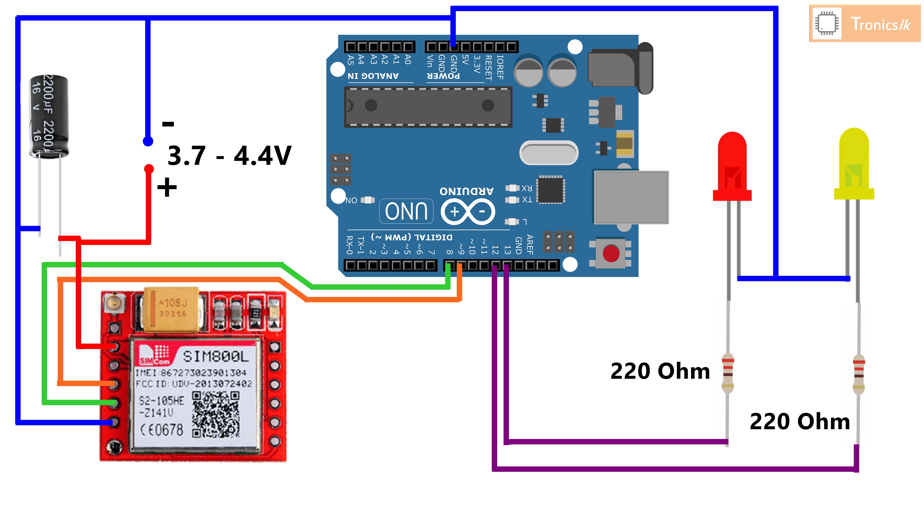

# HARDWARE REQUIREMENTS

* Arduino Uno

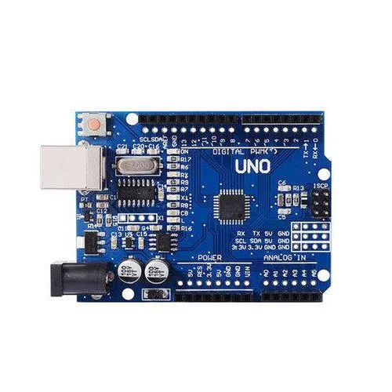

* SIM800l GSM Module

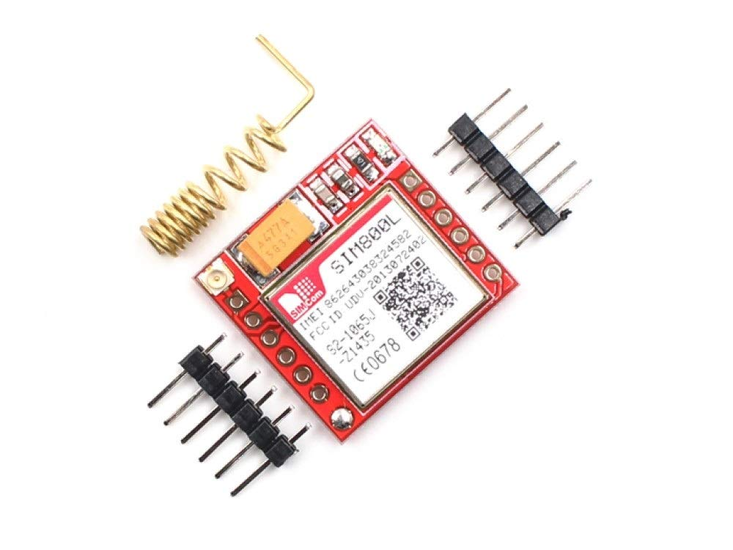

* 12V, 2amp power supply
* 2 LED’S
* Jumper Wires
* 1K resistor
* Breadboard
* 4007 Diode
* 2200uf Capacitor

# SOFTWARE REQUIREMENT

**Arduino Software (IDE)**

The Arduino Integrated Development Environment - or Arduino Software (IDE) - contains a text editor for writing code, a message area, a text console, a toolbar with buttons for common functions and a series of menus. It connects to the Arduino hardware to upload programs and communicate with them.

**Operating System:** Windows/Linux/ Mac PC

**Processor:** At least i3 processor

**RAM:** minimum 4GB

**Screen Resolution:** 1280 x 800

**Disk Space:** minimum 2–4GB

# CONCLUSION & SCOPE OF THE PROJECT

The development of a GSM-based home automation system is presented. The system enables

one remotely control electrical appliances requiring 220/240V 50Hz power source (such as refrigerators and water heaters) from anywhere in the world. This is achieved by simply sending an SMS command to a dedicated SIM card embedded in the system. It is recommended that the system is enhanced to provide feedback to the user in other to know the system status after each controlled operation carried out.